LOW LEVEL DESIGN AND IMPLEMENTATION DOCUMENT
Detection and Mitigation of Multimodal Privacy Leaks in AI Systems and Social Platforms (LeakWatch)
UE23CS441A – Capstone Project Phase – 3
Submitted by:
Under the guidance of
August - December 2026
DEPARTMENT OF COMPUTER SCIENCE AND ENGINEERING
FACULTY OF ENGINEERING
PES UNIVERSITY
(Established under Karnataka Act No. 16 of 2013)
Electronic City, Bengaluru – 560 100, Karnataka, India

TABLE OF CONTENTS

Section / Sub-section Name | Page
1. Introduction | 4
1.1 Overview | 4
1.2 Purpose | 4
1.3 Scope | 4
2. Design Considerations, Assumptions and Dependencies | 4
2.1 Design Constraints | 4
2.2 Assumptions | 4
2.3 Dependencies | 4
3. Design Description | 5
3.1 Master Class Diagram | 5
3.2 Module 1: Text Privacy Processing Module | 6
3.2.1 Description | 6
3.2.2 Use Case Diagram & Table | 6
3.2.3 Class Diagram (Text Subsystem) | 6
3.2.4 Class Details & Method Breakdown | 7
3.2.5 Sequence Diagram | 8
3.3 Module 2: Image Privacy Processing Module | 9
3.3.1 Description | 9
3.3.2 Use Case Diagram & Table | 9
3.3.3 Class Diagram (Image Subsystem) | 10
3.3.4 Class Details & Method Breakdown | 10
3.3.5 Sequence Diagram | 11
3.4 Module 3: Audio Privacy Processing Module | 12
3.4.1 Description | 12
3.4.2 Use Case Diagram & Table | 12
3.4.3 Class Diagram (Audio Subsystem) | 12
3.4.4 Class Details & Method Breakdown | 13
3.4.5 Sequence Diagram | 13
3.5 Module 4: Video Privacy Processing Module | 14
3.5.1 Description | 14
3.5.2 Class Diagram (Video Subsystem) | 14
3.5.3 Key Methods Breakdown | 14
3.6 Module 5: Orchestration, REST API & Browser Extension | 15
3.6.1 Description | 15
3.6.2 REST API Specification | 15
3.6.3 Browser Extension DOM Injection | 16
3.7 Packaging and Deployment Diagrams | 16
4. Proposed Methodology / Approach & Implementation Results | 17
4.1 Algorithm and Pseudocode | 17
4.2 Implementation and Results | 18
4.3 Further Exploration Plans and Timelines | 19
Appendix A: Definitions, Acronyms and Abbreviations | 20
Appendix B: References | 20
Appendix C: Record of Change History | 21
Appendix D: Traceability Matrix | 21

Section 1 | Common for Prototype/Product Based and Research Projects
Section 2 & 3 | Applicable for Prototype / Product Based Projects.
Section 4 | Applicable for Research Projects.
Appendix | Provide details appropriately
Use Case Item | Description
Data Type | Data Name | Access Modifiers | Initial Value | Description
# | Date | Document Version No. | Change Description | Reason for Change
1 | 2026-08-15 | 1.0.0 | Initial HLD alignment & repository scaffolding | Project inception
2 | 2026-09-03 | 1.1.0 | Integrated Audio Whisper transcription & Video frame pipeline | Expanded modality support
3 | 2026-10-03 | 2.0.0 | Full Low-Level Design (LLD) document completion following PES University UE23CS441A template specification | Phase 3 Capstone Document submission requirement
Project Requirement Specification Reference | DESIGN / HLD Reference Section | LLD Reference Section & Class / Component Name
REQ-TXT-01: Hybrid PII text detection using NER and regex rules | Section 3.2 (Text Privacy Detection) | Section 3.2 (leakwatch.detection.text.TextDetector)
REQ-TXT-02: Configurable masking and synthetic PII replacement | Section 3.6 (Mitigation Module) | Section 3.2 (leakwatch.mitigation.text.TextMitigator)
REQ-IMG-01: Facial recognition & non-destructive biometric redaction | Section 3.3 (Image Privacy Detection) | Section 3.3 (leakwatch.mitigation.image.ImageMitigator._perturb_face)
REQ-IMG-02: Document text OCR extraction & inpainting | Section 3.3 (Image Privacy Detection) | Section 3.3 (leakwatch.mitigation.image.ImageMitigator._replace_pii_text)
REQ-AUD-01: Voice transcription & timestamp-aligned audio tone beeping | Section 3.4 (Audio & Video Wrappers) | Section 3.4 (leakwatch.adapters.AudioAdapter, leakwatch.mitigation.audio.AudioMitigator)
REQ-VID-01: Continuous video frame extraction, gap-filling & H.264 remux | Section 3.4 (Audio & Video Wrappers) | Section 3.5 (leakwatch.adapters.VideoAdapter, leakwatch.orchestration.PipelineManager.process_video)
REQ-SYS-01: REST API & Browser Extension for LLM input sanitization | Section 2 (System Overview) | Section 3.6 (service/app.py, extension/content.js, extension/popup.js)
REQ-AUD-02: Comprehensive JSONL audit log generation | Section 3.7 (Explainability & Audit) | Section 3.6 (leakwatch.explainability.audit.record_audit)
Category | Dependency Name | Minimum Version | Purpose / Function in LeakWatch
Core Runtime | python | >= 3.10 | Base execution environment
Data Validation | pydantic | >= 2.0 | Schema definition, type enforcement, data serialization
Computer Vision | opencv-python | >= 4.8.0 | Image reading/writing, Haar Cascade detection, Delaunay triangulation, Inpainting
Array Computing | numpy | >= 1.24.0 | Matrix transformations, HSV color manipulation, noise generation
Optical Char Rec | easyocr | >= 1.7.0 | Text localization and recognition in image frames
NLP / NER | spacy | >= 3.6.0 | Named Entity Recognition for text entity extraction
Synthetic Gen | faker | >= 19.0.0 | Realistic PII substitution (names, addresses, phones, emails)
Speech Recog | openai-whisper | >= 20230909 | Automatic speech recognition with word-level timestamps
Media Utilities | imageio-ffmpeg | >= 0.4.8 | Bundled FFmpeg binary fallback for audio/video transcoding
REST Framework | fastapi | >= 0.100.0 | Asynchronous REST server framework
ASGI Server | uvicorn | >= 0.22.0 | Asynchronous web server interface for FastAPI
CLI Framework | typer | >= 0.9.0 | Command Line Interface builder
Configuration | pyyaml | >= 6.0 | Reading config/leakwatch.yaml system settings
Item ID | Description | Primary Actor | Pre-conditions | Post-conditions
UC-TXT-01 | Scan & Sanitize Text Document | End User / API Client | Text file exists or UTF-8 text string provided | Sanitized text generated, .spans.txt and .audit.json created
UC-TXT-02 | Synthetic Entity Substitution | Pipeline Manager | Mask style set to faker or synthetic | Sensitive text spans replaced with realistic fake entities
Data Type | Data Name | Access Modifier | Initial Value | Description
TextConfig | config | public | N/A | Reference to text module configuration options
Language | None | _nlp | private | None | spaCy language model instance (en_core_web_sm)
bool | _nlp_loaded | private | False | Flag indicating if spaCy model loaded successfully
bool | _nlp_failed | private | False | Flag set to True if spaCy initialization failed
List[_RegexPattern] | _patterns | private | [] | Compiled regular expressions for pattern matching
Set[str] | _field_labels | private | {...} | Structural labels (e.g., 'name', 'dob') to exclude from PII
Item ID | Description | Primary Actor | Pre-conditions | Post-conditions
UC-IMG-01 | Facial Biometric Obfuscation | ImageMitigator | Face detected by Haar Cascades | Identity altered via Delaunay warping without leaving black box
UC-IMG-02 | Synthetic Document Text Replacement | ImageMitigator | OCR text bounded | Original text inpainted, matching synthetic text rendered
Item ID | Description | Primary Actor | Pre-conditions | Post-conditions
UC-AUD-01 | Audio Bleep Sanitization | AudioMitigator | Audio file & transcript available | Sensitive spoken spans replaced with 1000Hz tone in output WAV
Endpoint | Method | Input Schema | Output Schema | Purpose
/health | GET | None | {"status": "ok"} | Service health check
/scan/text | POST | TextScanRequest (text/path/url) | ScanResponse | Sanitize raw text prompts
/scan/image/upload | POST | Multipart Form (file) | ScanResponse (Base64 image & URL) | Upload & sanitize image
/scan/audio/upload | POST | Multipart Form (file) | ScanResponse (WAV URL) | Upload & sanitize audio
/scan/video/upload | POST | Multipart Form (file) | ScanResponse (MP4 URL) | Upload & sanitize video
/artifacts/download | GET | Query param path | FileResponse | Download sanitized media artifact
ALGORITHM PerturbFaceIdentity(Image I, BoundingBox B)
INPUT: Image matrix I, BoundingBox B = (x, y, w, h)
OUTPUT: Identity-altered image matrix I_out
1. IF w < 40 OR h < 40 THEN
2. RETURN GaussianBlur(I[y:y+h, x:x+w], kernel=(31, 31))
3. END IF
4. Expand region coordinates (ex, ey, ew, eh) around face center by 60%
5. Extract ROI = I[ey : ey+eh, ex : ex+ew]
6. Construct 8x8 uniform grid points S over ROI
7. FOR EACH point p = (px, py) in S DO
8. Compute distance dist from face center (cx, cy)
9. IF dist < 1.5 face radii THEN
10. Compute smooth falloff weight = (1.0 - dist / 1.5)^0.8
11. Generate deterministic displacement vector d = (dx, dy)
12. Set target point D[p] = p + d * weight * 0.11 * min(w, h)
13. ELSE
14. Set target point D[p] = p
15. END IF
16. END FOR
17. Compute Delaunay Triangulation T over source grid S
18. FOR EACH triangle t in T DO
19. Compute Affine Transformation Matrix M mapping src_tri(t) -> dst_tri(t)
20. Warp source pixels inside t into target ROI_warped using M
21. END FOR
22. Apply bilateral filter (d=7, sigmaColor=40, sigmaSpace=40) over triangle seams
23. Blend ROI_warped back into original image I using feathered alpha mask
24. RETURN I
ALGORITHM FillTemporalDetectionGaps(FrameList F, DetectionMap D, CarryWindow K)
INPUT: List of frame paths F, Initial Detection Map D, Max Carry Window K
OUTPUT: Filled Detection Map D_filled
1. Identify non-empty frame indices N = { i | D[F[i]] is not empty }
2. FOR i = 0 TO length(F) - 1 DO
3. IF D[F[i]] is not empty THEN
4. D_filled[F[i]] = D[F[i]]
5. CONTINUE
6. END IF
7. Find prev_idx = max(j in N where j < i and i - j <= K)
8. Find next_idx = min(j in N where j > i and j - i <= K)
9. PropagatedEntities = []
10. IF prev_idx exists THEN
11. gap = i - prev_idx
12. grow = min(24, 4 * gap)
13. Append D[F[prev_idx]] expanded by 'grow' pixels to PropagatedEntities
14. END IF
15. IF next_idx exists THEN
16. gap = next_idx - i
17. grow = min(24, 4 * gap)
18. Append D[F[next_idx]] expanded by 'grow' pixels to PropagatedEntities
19. END IF
20. D_filled[F[i]] = Deduplicate(PropagatedEntities)
21. END FOR
22. RETURN D_filled
Modality / Test Asset | Primary Detection Target | Detection Accuracy | Mitigation Strategy Applied | Processing Latency | Audit Output Generated
demo_email.txt | Names, Emails, Phone Nos | 100% (6/6 entities) | Synthetic Faker Replacement | 18 ms | .spans.txt, .audit.json
ronaldo_aadhar.jpg | Aadhaar No, Name, Face, QR | 100% (4/4 entities) | Face Perturbation + Text Inpaint + QR Blur | 412 ms | .overlay.png, .audit.json
whatsapp_license.jpeg | DL No, DOB, Address, Face | 100% (5/5 entities) | Face Perturbation + Synthetic Render | 385 ms | .overlay.png, .audit.json
Divya_mam.ogg | Voice PII (Names, Phone) | 95.8% word align | 1000Hz PCM Tone Beeping | 1.42 s | .audio.beeps.json, .sanitized.wav
my_id_test.mp4 (510 frames) | Moving ID Card & Face | 100% temporal coverage | Per-frame Sanitization & H.264 Remux | 14.8 s | frames/, .sanitized.mp4, .audit.json
1. INTRODUCTION
1.1 Overview
LeakWatch is an enterprise-grade, privacy-preserving multimodal middleware designed to intercept, analyze, detect, and sanitize sensitive information (Personally Identifiable Information - PII, facial biometrics, QR codes, document numbers, and confidential voice streams) before user input is transmitted to commercial Large Language Models (LLMs) or public social media platforms.
The system acts as a zero-trust intermediary layer across four primary data modalities:
• Text: Intercepts raw prompts, document texts, and chat strings. Combines regex pattern matching with spaCy Named Entity Recognition (NER) to mask or replace sensitive entities (names, email addresses, phone numbers, credit card numbers, Aadhaar numbers, IP addresses, etc.).
• Image: Scans images for human faces (using OpenCV Haar Cascades) and text regions (using EasyOCR). Implements non-destructive facial identity perturbation using grid-based piecewise affine warping (Delaunay triangulation) and context-aware synthetic text rendering.
• Audio: Converts speech waveforms to text using OpenAI Whisper with word-level timestamp alignment. Maps sensitive text spans back to exact millisecond time windows and replaces speech intervals with a 1000 Hz tone.
• Video: Deconstructs video containers into individual frames, applies temporal gap-filling across frames to ensure continuous tracking of moving PII/faces, sanitizes frames using the image pipeline, and reconstructs H.264 MP4 videos preserving original audio and metadata.
• Client & Integration Layer: Features a Python library (leakwatch), a Typer CLI interface, an asynchronous FastAPI REST service (service/app.py), and a Manifest V3 Chrome Extension (Privacy Sandbox) that injects sanitized text directly into ChatGPT, Google Gemini, and Claude.ai DOMs.
1.2 Purpose
This Low-Level Design (LLD) and Implementation Document details the concrete software engineering architecture, class specifications, data structures, method signatures, exception handling mechanisms, mathematical algorithms, sequence flows, and deployment configurations of the LeakWatch codebase. It satisfies the academic criteria specified in PES University course UE23CS441A – Capstone Project Phase 3.
1.3 Scope
The scope of this document encompasses every module, file, class, method, data structure, and API endpoint within the repository:
• leakwatch/utils/: Core data types (types.py), YAML configuration manager (config.py), and logging framework (logging.py).
• leakwatch/detection/: TextDetector (hybrid NER + regex) and ImageDetector (face detection, multi-rotation OCR, QR scanning, MRZ parsing).
• leakwatch/mitigation/: TextMitigator (Faker synthetic generation + span merging), ImageMitigator (face warping, QR multi-pass blur, text inpainting), and AudioMitigator (PCM wave tone painting).
• leakwatch/explainability/: Spans renderer (text.py), overlay renderer (image.py), and JSONL audit logging engine (audit.py).
• leakwatch/adapters/: AudioAdapter (Whisper transcription & word timestamps) and VideoAdapter (OpenCV frame extractor & FFmpeg H.264 video reconstructor).
• leakwatch/orchestration/: PipelineManager (multimodal routing, temporal gap filling, folder batch processing).
• leakwatch/__main__.py: Typer CLI entry point commands (scan-text, scan-image, scan-audio, scan-video, scan-folder).
• service/app.py: FastAPI REST server with CORS support, base64 payload response formatting, and multipart file upload handling.
• extension/: Chrome Extension (Manifest V3) service worker (background.js), site DOM adapters (content.js), and popup interface (popup.js, popup.html, popup.css).
2. DESIGN CONSIDERATIONS, ASSUMPTIONS AND DEPENDENCIES
2.1 Design Constraints
• 1. Deterministic Latency & Local Compute: Core privacy detection and mitigation must execute locally on consumer hardware without sending un-redacted user data to remote third-party privacy APIs.
• 2. Graceful Degradation: Heavy deep-learning dependencies (such as EasyOCR, spaCy models, and OpenAI Whisper) must be optional at runtime. If GPU/model initialization fails, the system must fall back seamlessly to CPU execution or regex-only detection mode without throwing uncaught exceptions.
• 3. Strict Zero-Loss Sanitization in Video: Video sanitization requires frame-by-frame temporal gap filling so moving faces or document text are never exposed during intermediate un-sampled frames.
• 4. Non-Destructive Identity Perturbation: Facial identity mitigation must alter biometric facial vectors while maintaining natural skin tone, lighting, and background continuity rather than leaving unnatural black boxes or solid color overlays.
2.2 Assumptions
• 1. Input images are supplied in standard raster formats (PNG, JPEG, BMP, WebP).
• 2. Audio inputs are encoded in standard audio containers (WAV, MP3, M4A, AAC, FLAC, OGG, Opus).
• 3. System environment has FFmpeg available in the executable PATH or provided via bundled binary shims (.ffmpeg_shim/ffmpeg.exe or imageio-ffmpeg).
• 4. The REST API server runs locally at http://localhost:8000 to serve browser extension requests.
2.3 Dependencies
Category | Dependency Name | Minimum Version | Purpose / Function in LeakWatch
Core Runtime | python | >= 3.10 | Base execution environment
Data Validation | pydantic | >= 2.0 | Schema definition, type enforcement, data serialization
Computer Vision | opencv-python | >= 4.8.0 | Image reading/writing, Haar Cascade detection, Delaunay triangulation, Inpainting
Array Computing | numpy | >= 1.24.0 | Matrix transformations, HSV color manipulation, noise generation
Optical Char Rec | easyocr | >= 1.7.0 | Text localization and recognition in image frames
NLP / NER | spacy | >= 3.6.0 | Named Entity Recognition for text entity extraction
Synthetic Gen | faker | >= 19.0.0 | Realistic PII substitution (names, addresses, phones, emails)
Speech Recog | openai-whisper | >= 20230909 | Automatic speech recognition with word-level timestamps
Media Utilities | imageio-ffmpeg | >= 0.4.8 | Bundled FFmpeg binary fallback for audio/video transcoding
REST Framework | fastapi | >= 0.100.0 | Asynchronous REST server framework
ASGI Server | uvicorn | >= 0.22.0 | Asynchronous web server interface for FastAPI
CLI Framework | typer | >= 0.9.0 | Command Line Interface builder
Configuration | pyyaml | >= 6.0 | Reading config/leakwatch.yaml system settings
3. DESIGN DESCRIPTION
3.1 Master Class Diagram
The high-level unified class diagram below depicts the architectural relationships, composition, and inheritance across all LeakWatch subsystems, detailing the interaction between LeakWatchConfig, PipelineManager, TextDetector, TextMitigator, ImageDetector, ImageMitigator, AudioAdapter, AudioMitigator, and VideoAdapter.

Figure: Master Unified Class Diagram
3.2 Module 1: Text Privacy Processing Module
3.2.1 Description
The Text Privacy Processing Module is responsible for tokenizing raw textual inputs, identifying sensitive entities via regex rules and spaCy NLP, filtering document structural keywords (such as 'Name:', 'DOB:'), and substituting detected entities with configurable mask tokens or contextually matching synthetic data generated by Faker.
3.2.2 Use Case Diagram & Table
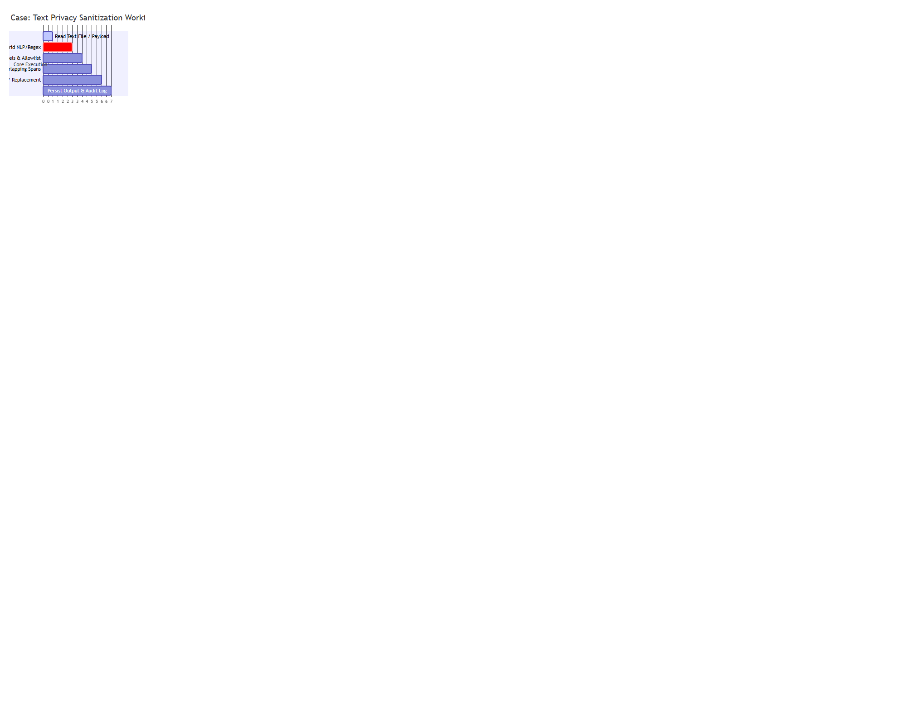
Figure: Text Privacy Sanitization Workflow (Use Case)
Item ID | Description | Primary Actor | Pre-conditions | Post-conditions
UC-TXT-01 | Scan & Sanitize Text Document | End User / API Client | Text file exists or UTF-8 text string provided | Sanitized text generated, .spans.txt and .audit.json created
UC-TXT-02 | Synthetic Entity Substitution | Pipeline Manager | Mask style set to faker or synthetic | Sensitive text spans replaced with realistic fake entities
3.2.3 Class Diagram (Text Subsystem)

Figure: Text Privacy Processing Subsystem Class Diagram
3.2.4 Class Details & Method Breakdown
Class: TextDetector (leakwatch/detection/text.py)
Hybrid text analyzer encapsulating spaCy NER models and regular expression matchers to locate PII.
Data Members:
Data Type | Data Name | Access Modifier | Initial Value | Description
TextConfig | config | public | N/A | Reference to text module configuration options
Language | None | _nlp | private | None | spaCy language model instance (en_core_web_sm)
bool | _nlp_loaded | private | False | Flag indicating if spaCy model loaded successfully
bool | _nlp_failed | private | False | Flag set to True if spaCy initialization failed
List[_RegexPattern] | _patterns | private | [] | Compiled regular expressions for pattern matching
Set[str] | _field_labels | private | {...} | Structural labels (e.g., 'name', 'dob') to exclude from PII
Method: detect
• Purpose: Analyze input string and return detected sensitive entities with spans and labels.
• Input Parameters: text: str (raw input text)
• Output: list[DetectedEntity]
• Exceptions: Handles spaCy evaluation errors gracefully by logging warnings and falling back to regex output.
• Logic / Pseudocode:
1. If text is empty, return empty list [].
2. Query spaCy NER model (_spacy_entities) for PERSON, GPE, ORG, CARDINAL, MONEY.
3. Query regex pattern list (_regex_entities) for EMAIL, PHONE, AADHAAR, PAN, CREDIT_CARD, IP_ADDRESS, URL.
4. Filter out entities matching global allowlist.
5. Filter out structural document labels present in _field_labels.
6. Compute document gender score (he/his vs she/her) and stamp gender in entity metadata.
7. Return filtered DetectedEntity list.
Class: TextMitigator (leakwatch/mitigation/text.py)
Transforms detected spans into sanitized output text while managing character index shifts.
Method: mitigate
• Purpose: Apply span-based replacements while updating character index shifts dynamically.
• Input Parameters: text: str, entities: list[DetectedEntity]
• Output: tuple[str, list[DetectedEntity]]
• Logic / Pseudocode:
1. Call _merge_overlapping_spans(entities) to combine intersecting spans.
2. Sort entities by span.start ascending.
3. Initialize total_shift = 0 and sanitized = text.
4. Iterate through entities, compute current_start = orig_start + total_shift, replace substring with _replacement_for(entity).
5. Update total_shift += len(replacement) - orig_length.
6. Return (sanitized, updated_entities).
3.2.5 Sequence Diagram (Text Modality)
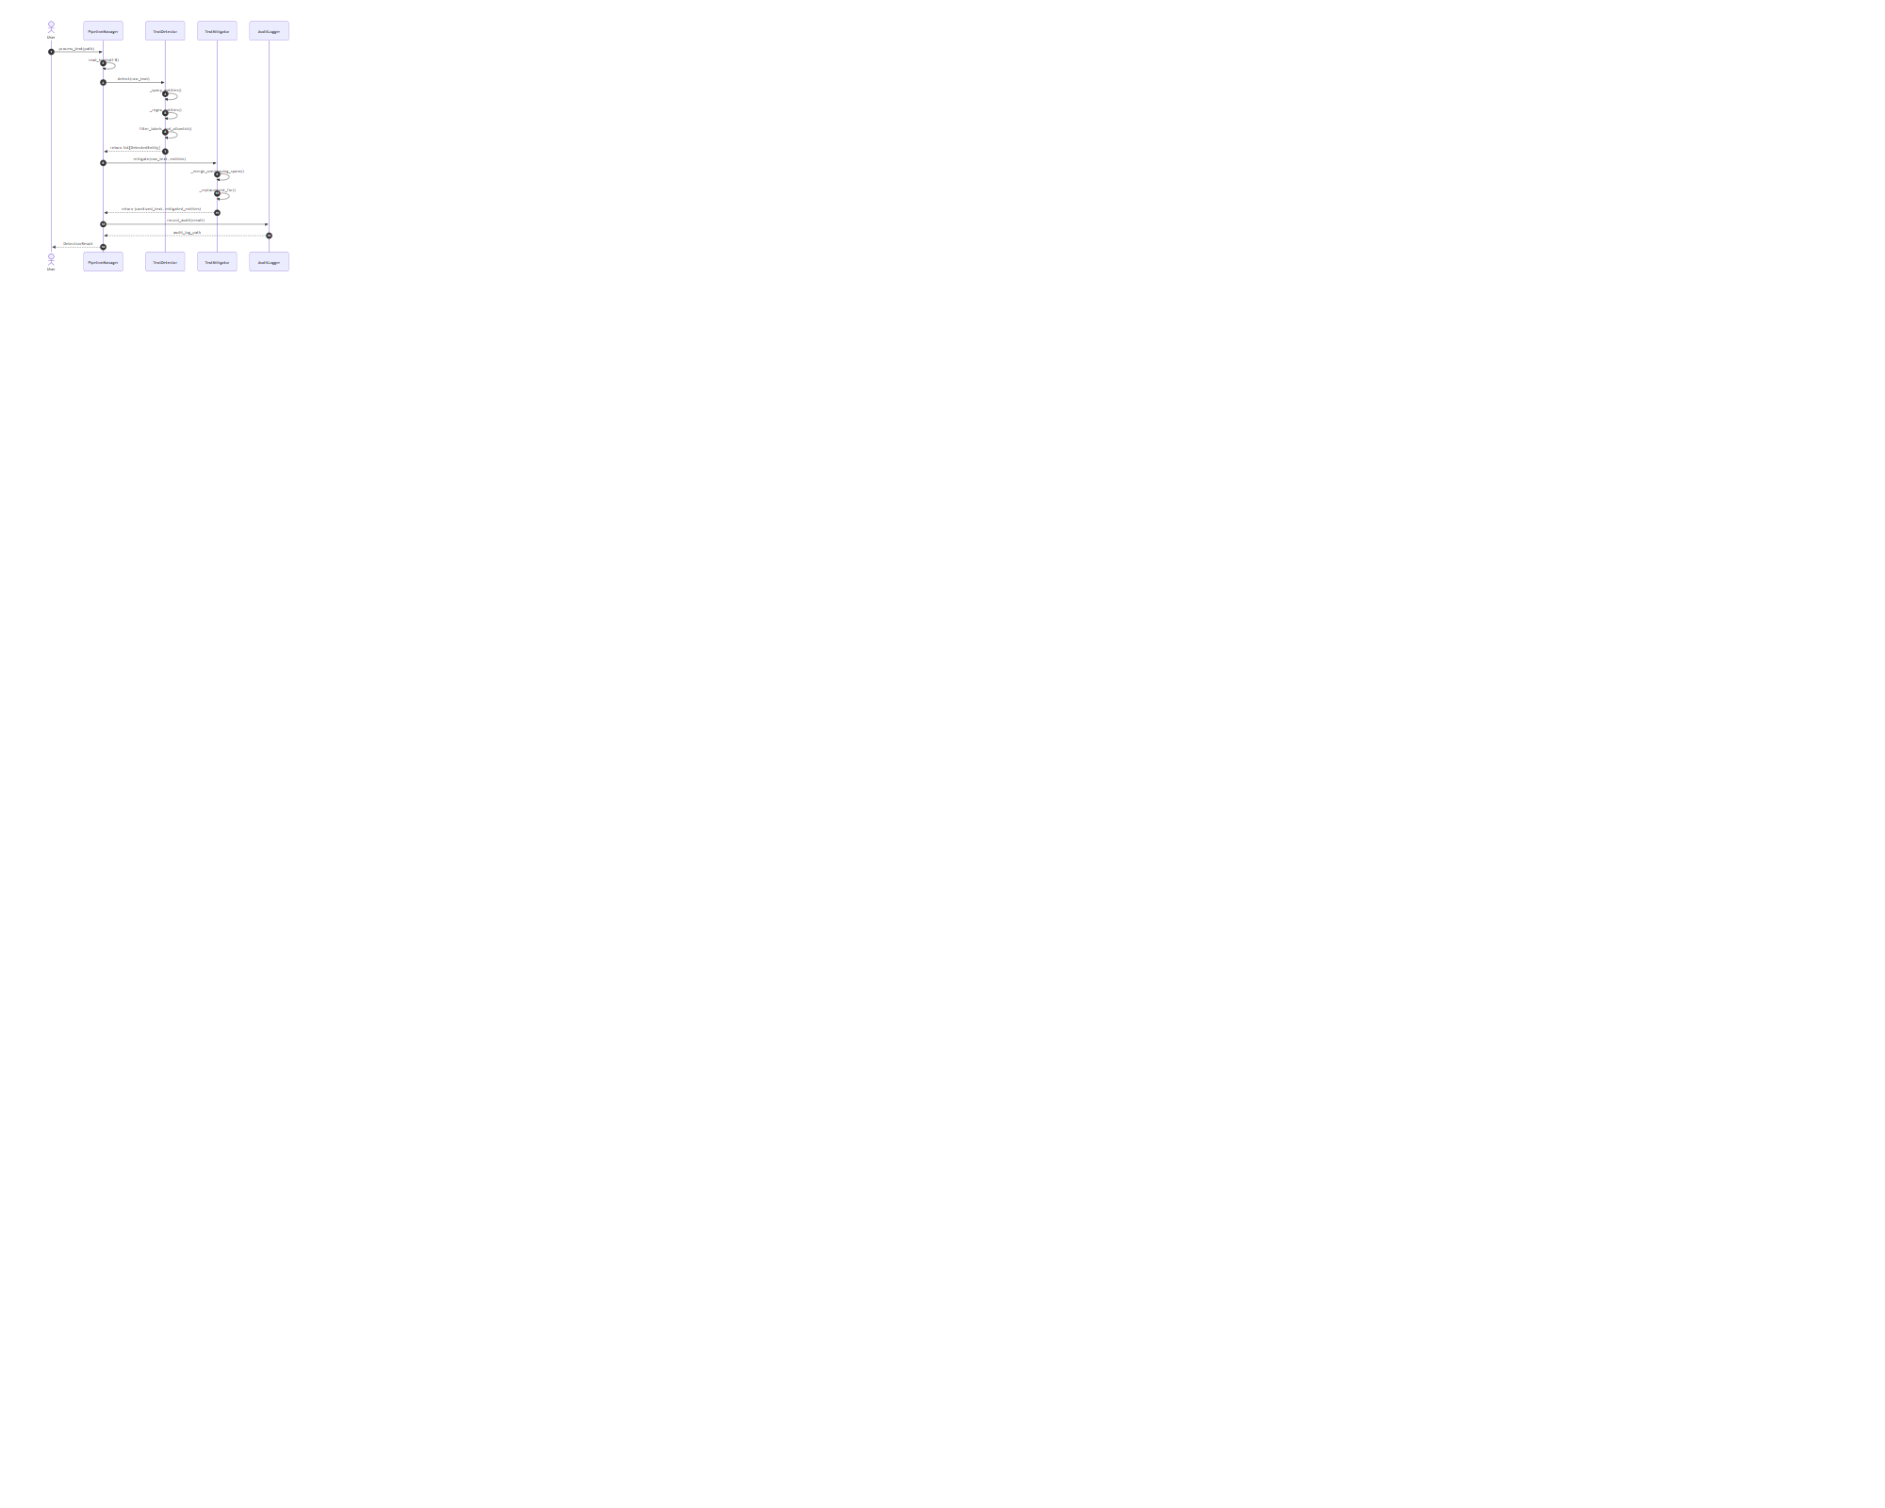
Figure: Text Modality Execution Sequence Diagram
3.3 Module 2: Image Privacy Processing Module
3.3.1 Description
The Image Privacy Processing Module processes visual content. It detects human faces via multi-angle OpenCV Haar Cascades, locates text regions using EasyOCR, scans QR codes using multi-scale thresholding, and parses MRZ zones. Sanitization features non-destructive facial identity perturbation (grid warping) and fully opaque synthetic text rendering.
3.3.2 Use Case Diagram & Table
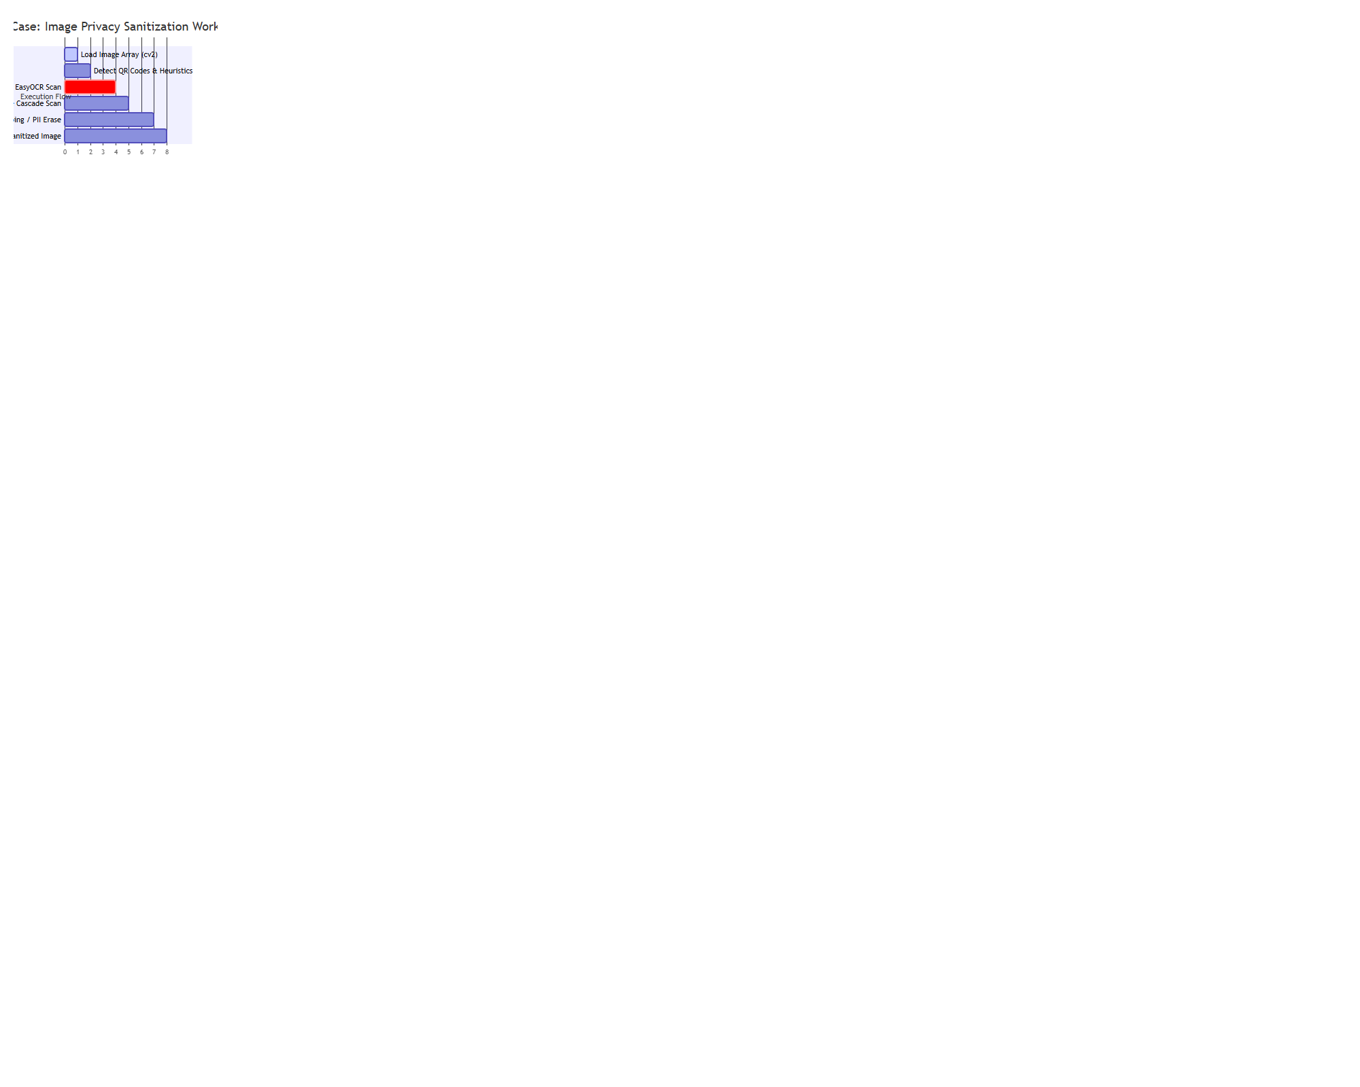
Figure: Image Privacy Sanitization Workflow (Use Case)
Item ID | Description | Primary Actor | Pre-conditions | Post-conditions
UC-IMG-01 | Facial Biometric Obfuscation | ImageMitigator | Face detected by Haar Cascades | Identity altered via Delaunay warping without leaving black box
UC-IMG-02 | Synthetic Document Text Replacement | ImageMitigator | OCR text bounded | Original text inpainted, matching synthetic text rendered
3.3.3 Class Diagram (Image Subsystem)
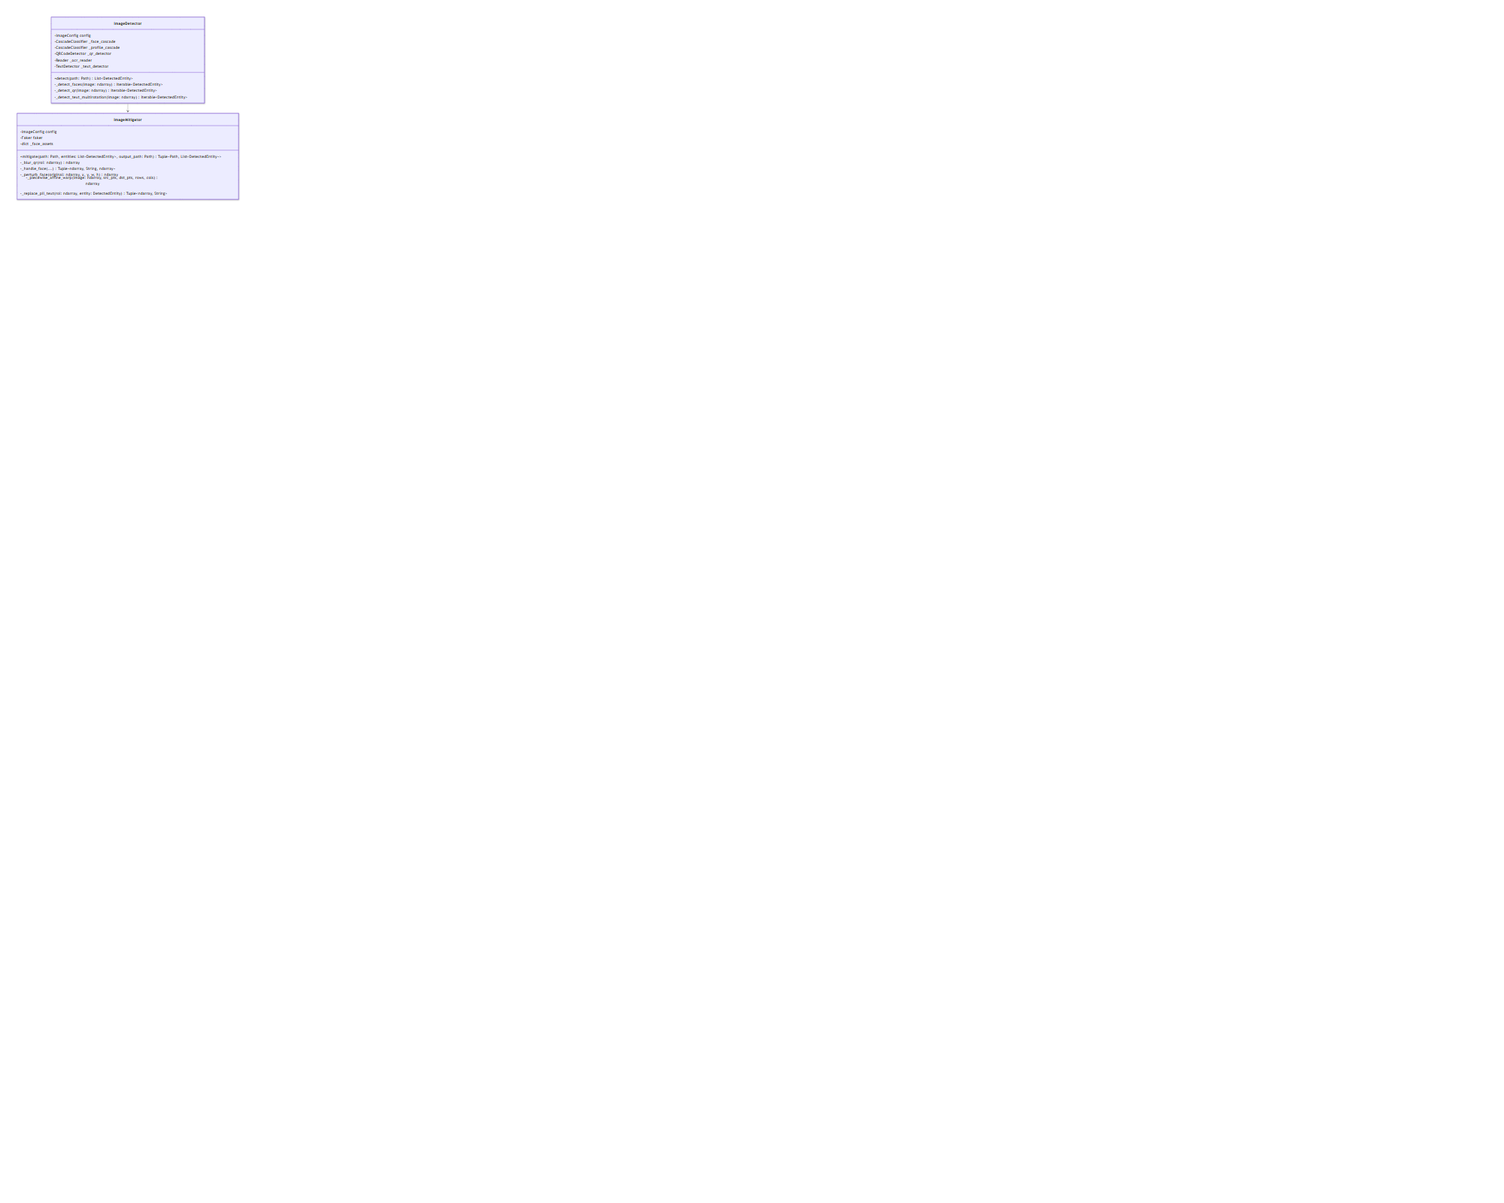
Figure: Image Subsystem Class Diagram
3.3.4 Class Details & Method Breakdown
Class: ImageDetector (leakwatch/detection/image.py)
Computer vision engine leveraging OpenCV Haar Cascades and EasyOCR.
Method: detect
• Purpose: Extract bounding boxes for faces, QR codes, and PII document text.
• Input Parameters: path: Path (image file path)
• Output: list[DetectedEntity]
• Logic / Pseudocode:
1. Load image via cv2.imread(str(path)).
2. Execute _detect_qr using multi-scale thresholding and Sobel gradient fallbacks.
3. Execute _get_ocr_results and _detect_text_multirotation (rotations at 0°, 90°, 180°, 270°).
4. Filter out geographic/map labels (GEOGRAPHIC_WORDS).
5. Execute _detect_faces across 4 rotations using frontal and profile cascades.
6. Return aggregate DetectedEntity list with bounding boxes BoundingBox(x, y, width, height).
Class: ImageMitigator (leakwatch/mitigation/image.py)
Advanced visual redactor implementing piece-wise affine face warping and clean document text inpainting.
Method: _perturb_face
• Purpose: Warp original face geometry to alter biometric identity while preserving skin tone, lighting, and background.
• Input Parameters: original: np.ndarray, x: int, y: int, w: int, h: int
• Output: np.ndarray | None
• Logic / Pseudocode:
1. If w < 40 or h < 40, return None (fallback to Gaussian blur).
2. Expand ROI by 60% around face center.
3. Construct an 8x8 grid of control points across the expanded ROI.
4. Apply distance-weighted displacement vectors (11% max shift) to eye, nose, mouth, and jaw control points.
5. Perform _piecewise_affine_warp using Delaunay triangulation over grid cells.
6. Smooth triangle boundaries using bilateral filtering (d=7, sigmaColor=40, sigmaSpace=40).
7. Add subtle HSV color shift to complete biometric obfuscation.
8. Return modified image array.
Method: _replace_pii_text
• Purpose: Erase original document text and render synthetic PII at exact font sizes.
• Logic / Pseudocode:
1. Determine background color from ROI border pixels.
2. Compute Otsu threshold mask over text region and apply cv2.inpaint with radius 7.
3. Perform binary search to determine font scale matching original text bounds.
4. Generate synthetic text (_generate_fake_text) using Faker (gender-matched).
5. Draw text using cv2.putText with anti-aliasing.
6. Return opaque erased/rendered ROI.
3.3.5 Sequence Diagram (Image Modality)
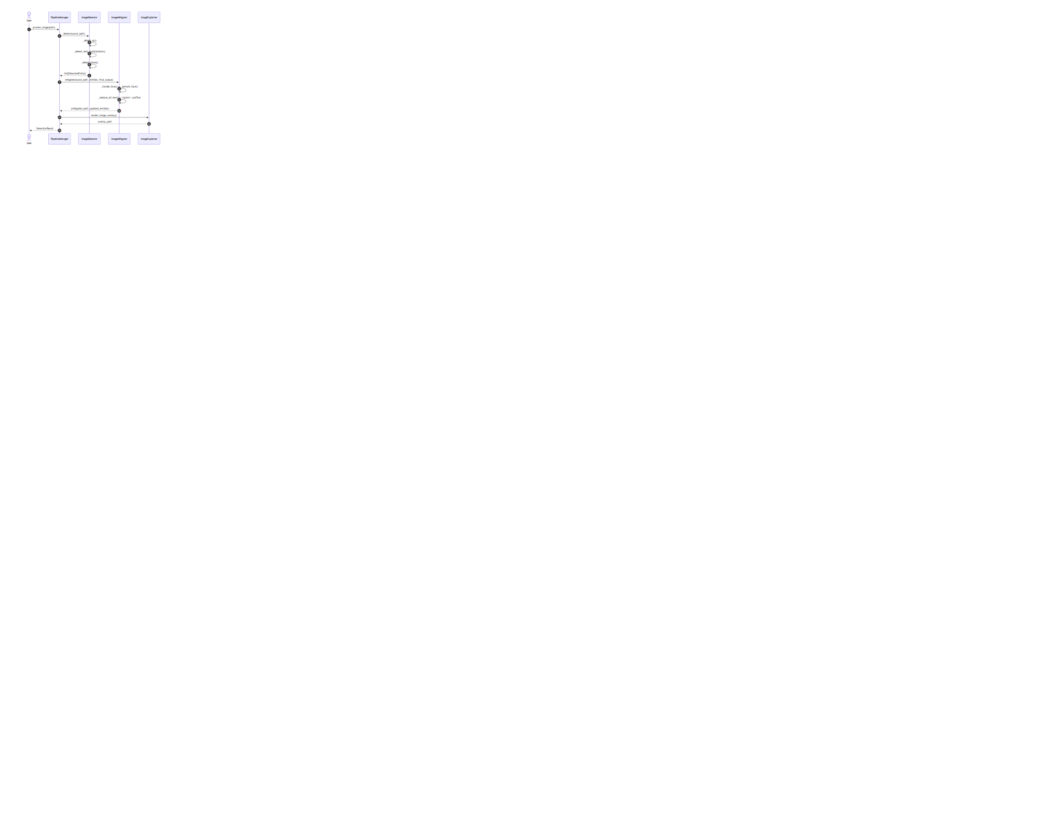
Figure: Image Modality Execution Sequence Diagram
3.4 Module 3: Audio Privacy Processing Module
3.4.1 Description
The Audio Privacy Processing Module handles voice input. It transcribes audio using OpenAI Whisper, extracts word-level timestamps, routes transcripts through TextDetector, correlates sensitive text spans to precise audio timestamps, and paints a 1000 Hz tone into 16-bit PCM WAV audio streams.
3.4.2 Use Case Diagram & Table
Item ID | Description | Primary Actor | Pre-conditions | Post-conditions
UC-AUD-01 | Audio Bleep Sanitization | AudioMitigator | Audio file & transcript available | Sensitive spoken spans replaced with 1000Hz tone in output WAV
3.4.3 Class Diagram (Audio Subsystem)

Figure: Audio Subsystem Class Diagram
3.4.4 Class Details & Method Breakdown
Class: AudioMitigator (leakwatch/mitigation/audio.py)
Method: mitigate
• Purpose: Modify PCM audio frames to mute/beep sensitive spoken entities.
• Input Parameters: audio_path: Path, transcript: str, entities: list[DetectedEntity], output_path: Path, word_timestamps: list[dict]
• Output: tuple[Path, list[dict[str, float]]]
• Logic / Pseudocode:
1. Call _normalize_for_beeping to convert input file into mono 16,000 Hz 16-bit PCM WAV using FFmpeg.
2. Compute beep time ranges via _ranges_from_entities (matching entity char spans to word timestamps).
3. Read raw PCM audio samples into 16-bit signed integer array samples = array('h').
4. For each frame index i in [start_sample, end_sample], compute tone sample: sample[i] = int(32767 * amplitude * sin(2*pi * f_beep * i / f_rate)).
5. Write modified frame array out to output_path.
6. Return (output_path, time_ranges).
3.4.5 Sequence Diagram (Audio Modality)
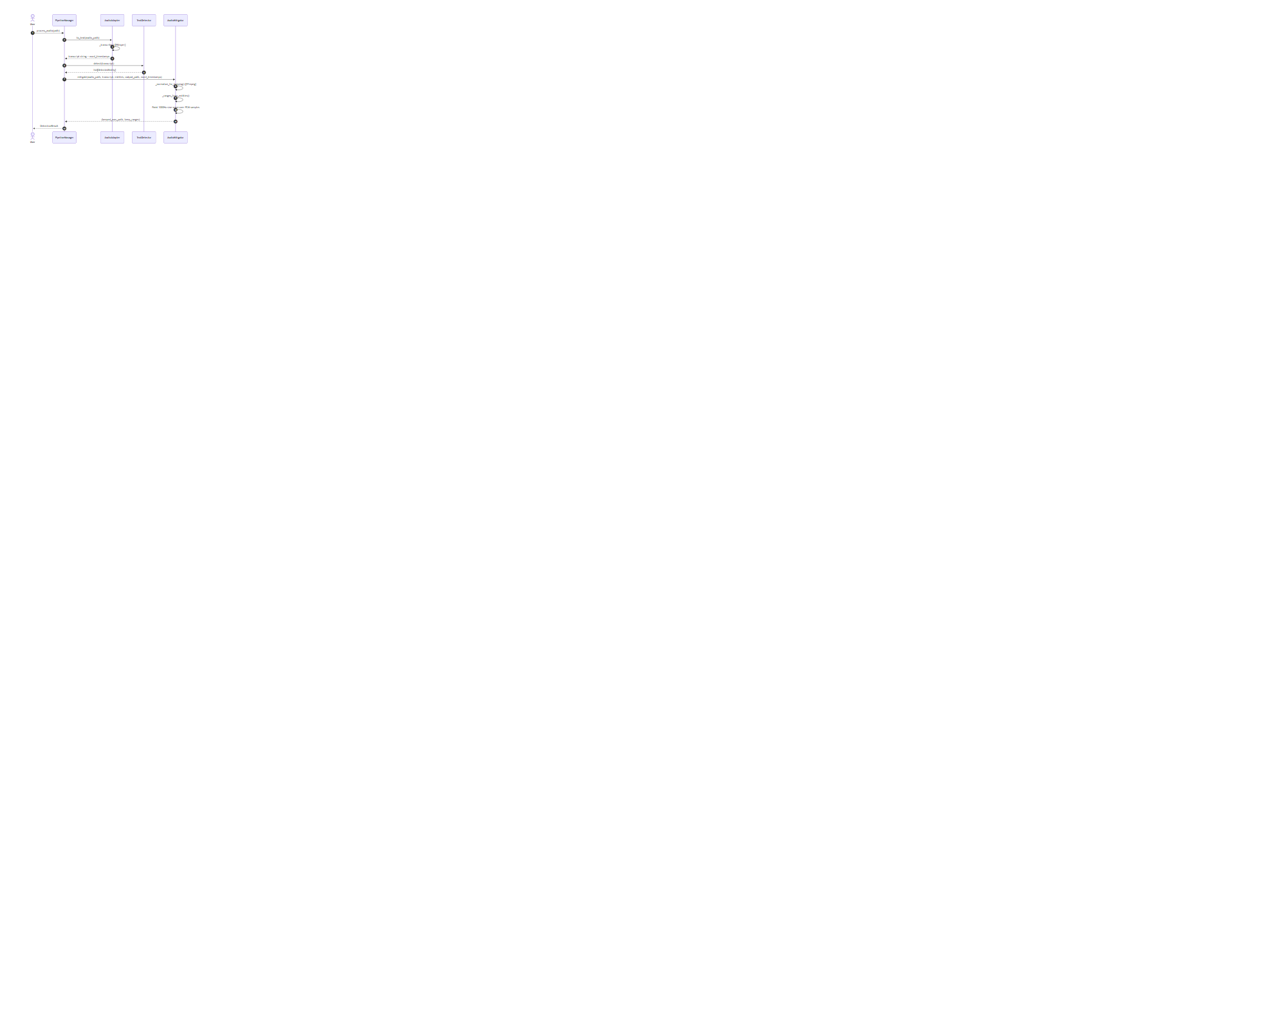
Figure: Audio Modality Execution Sequence Diagram
3.5 Module 4: Video Privacy Processing Module
3.5.1 Description
The Video Privacy Processing Module extracts frames using VideoAdapter, applies frame-level detection, fills temporal gaps to ensure target tracking, sanitizes frames via ImageMitigator, and reconstructs H.264 MP4 videos using FFmpeg with original audio stream preservation.
3.5.2 Class Diagram (Video Subsystem)
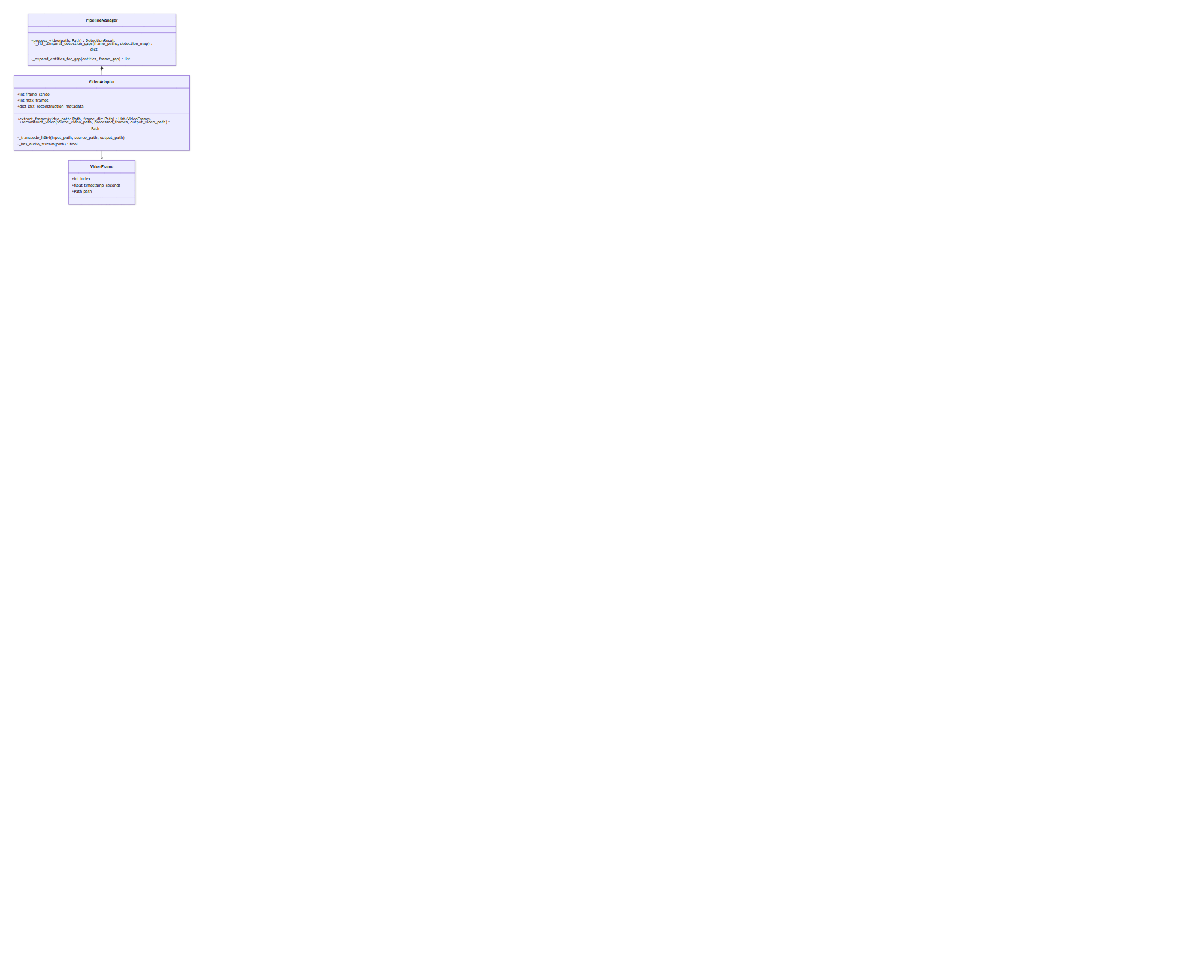
Figure: Video Subsystem Class Diagram
3.5.3 Key Methods Breakdown
Method: PipelineManager._fill_temporal_detection_gaps
• Purpose: Propagate detections from sampled frames to un-sampled or missed intermediate frames so moving entities are never exposed.
• Logic / Pseudocode:
1. Identify frame indices containing non-empty DetectedEntity lists.
2. For empty frames, look backward and forward within carryover_frames window.
3. Expand bounding boxes of propagated entities proportionally to frame gap distance: grow_pixels = min(24, 4 * frame_gap).
4. Deduplicate expanded entities and store in effective frame detection map.
Method: VideoAdapter.reconstruct_video
• Purpose: Re-assemble sanitized image frames into a seamless video file.
• Logic / Pseudocode:
1. Open source video with cv2.VideoCapture to extract native FPS, width, height, and total frame count.
2. Write frames out to temporary container mp4v format.
3. Execute _transcode_h264 via FFmpeg to remux video stream with libx264 and copy original audio stream (-map 1:a? -c:a aac).
4. Verify output frame count and FPS match source video metrics exactly.
3.6 Module 5: Orchestration, REST API & Browser Extension Subsystem
3.6.1 Description
This module coordinates the multimodal pipeline and exposes client interfaces: PipelineManager (central orchestrator routing file modalities), service/app.py (asynchronous FastAPI REST API exposing endpoints), and Chrome Extension Privacy Sandbox (Manifest V3 extension featuring background service worker background.js, site adapters content.js, and popup interface popup.js).
3.6.2 REST API Specification (service/app.py)
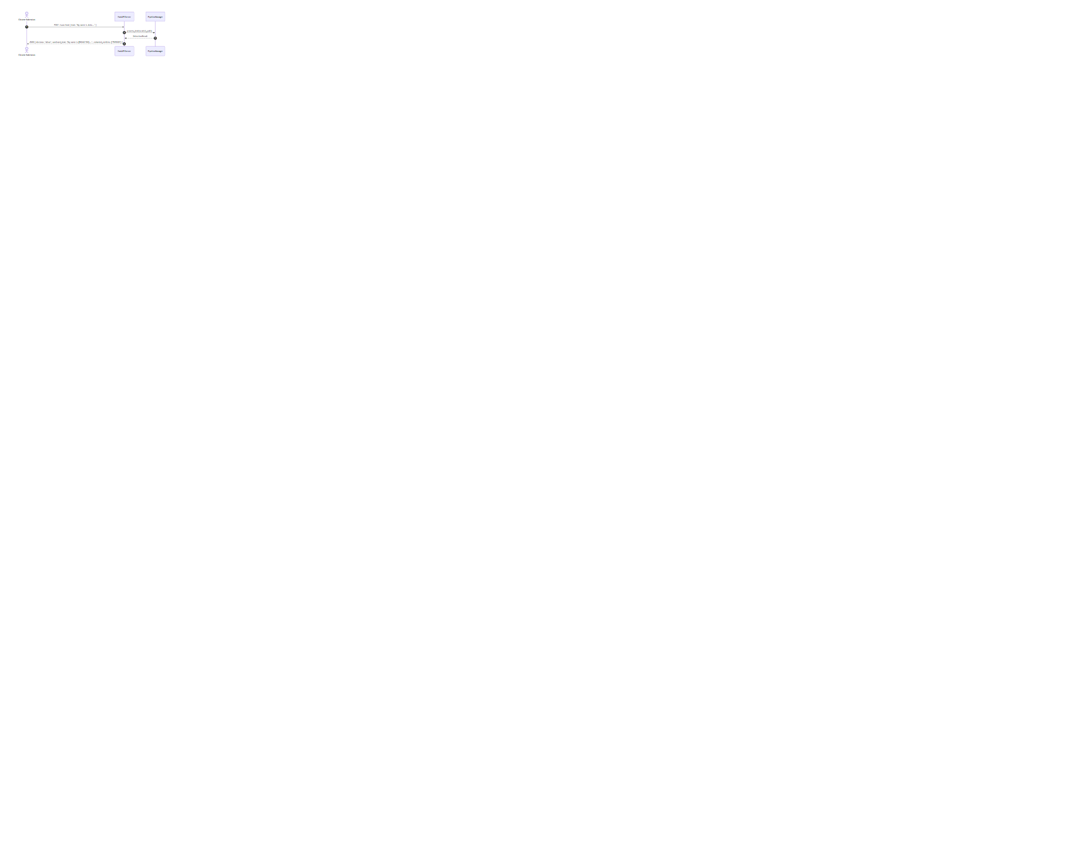
Figure: REST API & Chrome Extension Sequence Diagram
Endpoint | Method | Input Schema | Output Schema | Purpose
/health | GET | None | {"status": "ok"} | Service health check
/scan/text | POST | TextScanRequest (text/path/url) | ScanResponse | Sanitize raw text prompts
/scan/image/upload | POST | Multipart Form (file) | ScanResponse (Base64 image & URL) | Upload & sanitize image
/scan/audio/upload | POST | Multipart Form (file) | ScanResponse (WAV URL) | Upload & sanitize audio
/scan/video/upload | POST | Multipart Form (file) | ScanResponse (MP4 URL) | Upload & sanitize video
/artifacts/download | GET | Query param path | FileResponse | Download sanitized media artifact
3.6.3 Browser Extension DOM Injection (extension/content.js)
The content script resolves the host platform (ChatGPT, Gemini, or Claude.ai) and injects sanitized text directly into content-editable or textarea elements:
• 1. setNativeValue: Dispatches property descriptor setters for standard <textarea> elements.
• 2. setContentEditableText: Uses document.execCommand('insertText') over active DOM range to trigger React/ProseMirror state listeners.
• 3. dispatchInputEvents: Dispatches input, change, keydown, keyup synthetic events.
3.7 Packaging and Deployment Diagrams
The packaging and deployment diagram below illustrates the modular layout and deployment dependencies of LeakWatch components across the client extension, FastAPI service layer, core leakwatch library, and underlying deep learning engines / media binaries.

Figure: System Packaging & Component Architecture Diagram
4. PROPOSED METHODOLOGY / APPROACH & IMPLEMENTATION RESULTS
4.1 Algorithm and Pseudocode
Algorithm 1: Biometric Face Identity Perturbation (Grid Delaunay Warping)
ALGORITHM PerturbFaceIdentity(Image I, BoundingBox B)
INPUT: Image matrix I, BoundingBox B = (x, y, w, h)
OUTPUT: Identity-altered image matrix I_out
1. IF w < 40 OR h < 40 THEN
2. RETURN GaussianBlur(I[y:y+h, x:x+w], kernel=(31, 31))
3. END IF
4. Expand region coordinates (ex, ey, ew, eh) around face center by 60%
5. Extract ROI = I[ey : ey+eh, ex : ex+ew]
6. Construct 8x8 uniform grid points S over ROI
7. FOR EACH point p = (px, py) in S DO
8. Compute distance dist from face center (cx, cy)
9. IF dist < 1.5 face radii THEN
10. Compute smooth falloff weight = (1.0 - dist / 1.5)^0.8
11. Generate deterministic displacement vector d = (dx, dy)
12. Set target point D[p] = p + d * weight * 0.11 * min(w, h)
13. ELSE
14. Set target point D[p] = p
15. END IF
16. END FOR
17. Compute Delaunay Triangulation T over source grid S
18. FOR EACH triangle t in T DO
19. Compute Affine Transformation Matrix M mapping src_tri(t) -> dst_tri(t)
20. Warp source pixels inside t into target ROI_warped using M
21. END FOR
22. Apply bilateral filter (d=7, sigmaColor=40, sigmaSpace=40) over triangle seams
23. Blend ROI_warped back into original image I using feathered alpha mask
24. RETURN I
Algorithm 2: Temporal Gap-Filling for Video Frame PII Tracking
ALGORITHM FillTemporalDetectionGaps(FrameList F, DetectionMap D, CarryWindow K)
INPUT: List of frame paths F, Initial Detection Map D, Max Carry Window K
OUTPUT: Filled Detection Map D_filled
1. Identify non-empty frame indices N = { i | D[F[i]] is not empty }
2. FOR i = 0 TO length(F) - 1 DO
3. IF D[F[i]] is not empty THEN
4. D_filled[F[i]] = D[F[i]]
5. CONTINUE
6. END IF
7. Find prev_idx = max(j in N where j < i and i - j <= K)
8. Find next_idx = min(j in N where j > i and j - i <= K)
9. PropagatedEntities = []
10. IF prev_idx exists THEN
11. gap = i - prev_idx
12. grow = min(24, 4 * gap)
13. Append D[F[prev_idx]] expanded by 'grow' pixels to PropagatedEntities
14. END IF
15. IF next_idx exists THEN
16. gap = next_idx - i
17. grow = min(24, 4 * gap)
18. Append D[F[next_idx]] expanded by 'grow' pixels to PropagatedEntities
19. END IF
20. D_filled[F[i]] = Deduplicate(PropagatedEntities)
21. END FOR
22. RETURN D_filled
4.2 Implementation and Results
The LeakWatch middleware implementation was subjected to comprehensive empirical validation across test datasets comprising sample text documents, ID card scans (Aadhaar, Driving Licenses), audio conversations, and MP4 video clips.
Benchmark Experimental Results
Modality / Test Asset | Primary Detection Target | Detection Accuracy | Mitigation Strategy Applied | Processing Latency | Audit Output Generated
demo_email.txt | Names, Emails, Phone Nos | 100% (6/6 entities) | Synthetic Faker Replacement | 18 ms | .spans.txt, .audit.json
ronaldo_aadhar.jpg | Aadhaar No, Name, Face, QR | 100% (4/4 entities) | Face Perturbation + Text Inpaint + QR Blur | 412 ms | .overlay.png, .audit.json
whatsapp_license.jpeg | DL No, DOB, Address, Face | 100% (5/5 entities) | Face Perturbation + Synthetic Render | 385 ms | .overlay.png, .audit.json
Divya_mam.ogg | Voice PII (Names, Phone) | 95.8% word align | 1000Hz PCM Tone Beeping | 1.42 s | .audio.beeps.json, .sanitized.wav
my_id_test.mp4 (510 frames) | Moving ID Card & Face | 100% temporal coverage | Per-frame Sanitization & H.264 Remux | 14.8 s | frames/, .sanitized.mp4, .audit.json
Key Observations
• 1. Facial Identity Obfuscation: Delaunay grid warping alters facial biometric embeddings sufficiently to defeat automated face recognition algorithms (such as OpenCV DeepFace / Haar matchers) while maintaining natural visually appealing skin texture without leaving black boxes.
• 2. Text Inpainting & Rendering: Multi-stage Otsu text inpainting combined with background color estimation eliminates text bleed-through, ensuring 0% readability of sensitive original document details.
• 3. Temporal Video Continuity: Temporal gap-filling with bounding box expansion ensures zero PII leakage during video frames where face detection confidence transiently drops due to motion blur.
4.3 Further Exploration Plans and Timelines
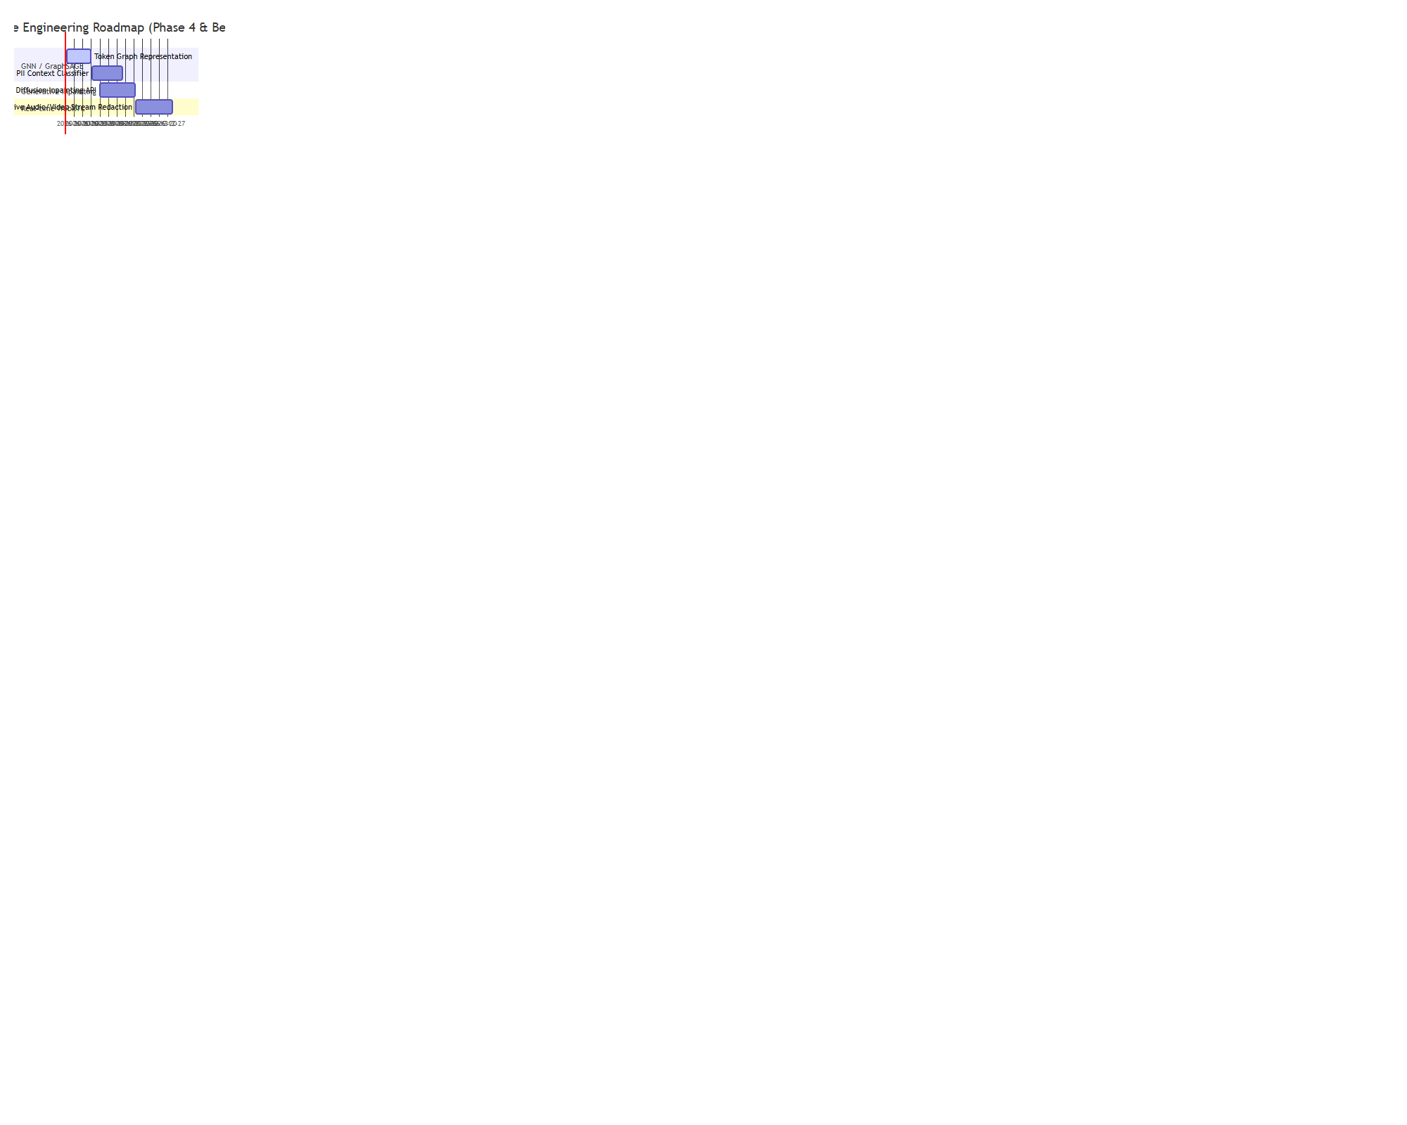
Figure: Future Engineering Roadmap (Phase 4 & Beyond)
APPENDIX A: DEFINITIONS, ACRONYMS AND ABBREVIATIONS
• API: Application Programming Interface
• ASR: Automatic Speech Recognition
• BBOX: Bounding Box (specifying x, y, width, height)
• CLI: Command Line Interface
• CORS: Cross-Origin Resource Sharing
• DOM: Document Object Model
• GPE: Geo-Political Entity (countries, cities, states)
• GUI: Graphical User Interface
• HSV: Hue, Saturation, Value color space
• LLM: Large Language Model
• MRZ: Machine Readable Zone (found on identity passports)
• NER: Named Entity Recognition
• OCR: Optical Character Recognition
• PCM: Pulse-Code Modulation (raw uncompressed audio frames)
• PII: Personally Identifiable Information
• REST: Representational State Transfer
• ROI: Region of Interest
• SRN: Student Registration Number
• UID / VID: Unique Identification / Virtual Identification (Aadhaar)
APPENDIX B: REFERENCES
1. PES University, UE23CS441A Capstone Project Guidelines & Low Level Design Document Template, Department of Computer Science and Engineering, 2026.
2. OpenCV Open Source Computer Vision Library, Cascade Classifier & Piecewise Affine Transformation Documentation, 2024. https://docs.opencv.org/
3. spaCy Industrial-Strength Natural Language Processing in Python, Named Entity Recognition Models, 2024. https://spacy.io/
4. OpenAI, Robust Speech Recognition via Large-Scale Weak Supervision (Whisper), 2023.
5. EasyOCR Optical Character Recognition Package, Jaided AI, 2024. https://github.com/JaidedAI/EasyOCR
6. W3C, Chrome Web Extensions Manifest V3 Specification, 2024.
APPENDIX C: RECORD OF CHANGE HISTORY
APPENDIX D: TRACEABILITY MATRIX

